# Design and Implementation of Any Time Electricity Bill Payment (ATP) Machine Controller

**Team Spark**

***Name 1***: Surepally Vishnnu Vardhini

***Name 2***: Aditya Kumar Sharma

***Institution***: Nitte Meenakshi Institute of Technology, Bangalore.

***Institution Mentor:***

Dr. Shashidhara K S, Professor, Dept of ECE.

***Industry Mentor:***

Mr. Abhishek Nandy, Intel Unnati.

Contents

Design and Implementation of Any Time Electricity Bill Payment (ATP) Machine Controller 1

I. BLOCK DIAGRAM 3

II. FSM 4

III. APPROACH 5

IV. METHODOLOGY/FLOW 5

RTL View: 13

Error: 13

V. GITHUB FILE SCREENSHOT 14

VI. RESULTS AND SUMMARIZATIONS 14

VII. REFERENCES 14

In this project, we have tried to design and implement an Any Time Electricity Bill Payment (ATP) Machine Controller using FPGA.

## **BLOCK DIAGRAM**

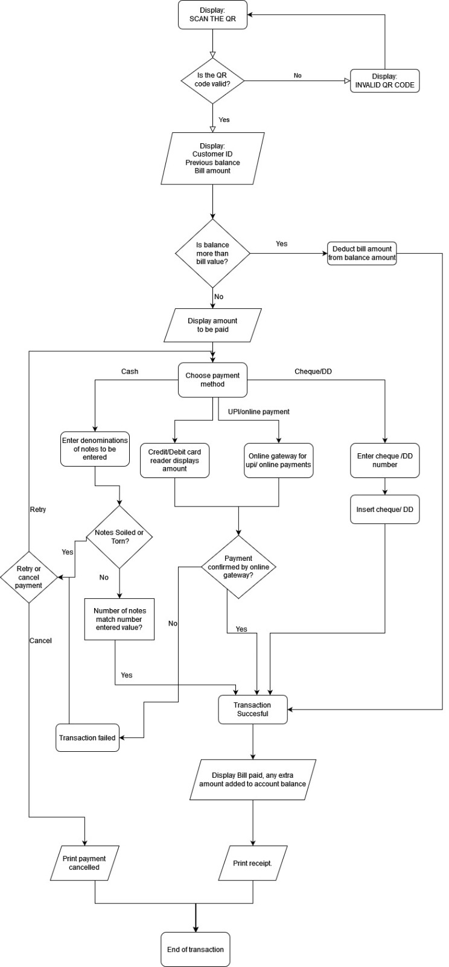

# FSM

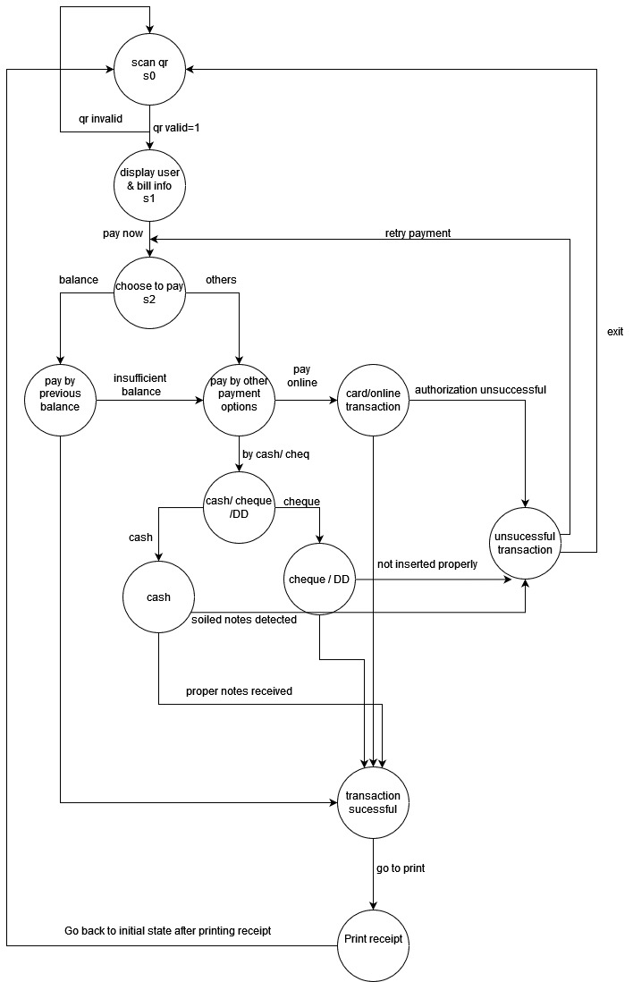

# **APPROACH**

1.In order to solve this problem, we drew a flowchart first which roughly summarizes our agenda and gives us a brief on methodology and how to work on it.

2. Users can pay through existing Balance, Cash, Card, Online Transactions, DD and Cheque.

3.The machine controller uses QR Scanner in order to initiate the process.

4.After the QR gets scanned, the machine controller displays Customer ID, Existing Balance, Amount to be paid and Pay option.

5.If Balance is greater than the Bill amount then the amount gets deducted automatically else the machine controller moves further and displays other payment options.

6.The machine controller displays QR for UPI payments, redirects to Online Gateway for Online payments, displays Insert DD or Cheque option for DD or Cheque and displays Insert Cash option for Cash mode of payment.

7.The machine controller does not accept soiled or torn notes.

8.If the transaction fails then the machine controller redirects to Retry Payment option.

9.If the transaction is successful then the machine controller displays Bill paid successfully and Extra amount to be added option.

10. If the user wants to add balance, then the machine controller redirects the user to choose payment mode option else the receipt is printed and transaction ends.

# **METHODOLOGY/FLOW**

1.Intel Quartus Prime Lite Software has been used to obtain results.

2.A Verilog HDL code and the test bench has been compiled successfully without errors to obtain the State Diagram of the given problem statement using block diagram as reference as shown in figure below.

***Verilog code:***

module atp (output reg [3:0] data_out,input in0,in1,in2,in3,in4,in5,in6,in7,in8,in9,in10,in11, input clk,rst);

parameter s0= 4'b0000; //scanqr

parameter s1= 4'b0001; //data display

parameter s2= 4'b0010; //balance or oth

parameter s3= 4'b0011; // pay by bal

parameter s4= 4'b0100; // pay by oths

parameter s5= 4'b0101; //pay caash or dd or cheq

parameter s6= 4'b0110; // card or upi

parameter s7= 4'b0111; //cash

parameter s8= 4'b1000; //dd/chq

parameter s9= 4'b1001; //FAIL

parameter s10=4'b1010; // success

parameter s11=4'b1011; // print receipt

reg [1:0] c_state,n_state;

always @(posedge clk)

begin

if (rst==1)

begin

c_state=0;

n_state=0;

end

else

c_state=n_state;

case(c_state)

s0: begin

if (in0==0) n_state = s0;

else if ( in0==1) n_state = s1;

end

s1: begin

if (in1==0) n_state = s0;

else if ( in1==1) n_state = s2;

end

s2: begin

if ( in2==0) n_state = s3;

else if ( in2==1) n_state = s4;

end

s3: begin

if (in3==0) n_state = s4;

else if ( in3==1) n_state = s10;

end

s4: begin

if (in4==0) n_state = s5;

else if (in4==1)n_state = s6;

end

s5: begin

if (in5==0) n_state = s7;

else if (in5==1)n_state = s8;

end

s6: begin

if (in6==0) n_state = s9;

else if (in6==1)n_state = s10;

end

s7: begin

if (in7==0) n_state = s9;

else if (in7==1)n_state = s10;

end

s8: begin

if (in8==0) n_state = s9;

else if (in8==1)n_state = s10;

end

s9: begin

if (in9==0) n_state = s4;

else if (in9==1)n_state = s0;

end

s10: begin

if (in10==0) n_state = s11;

else if (in10==1)n_state = s11;

end

s11: begin

if (in11==0) n_state = s0;

else if (in11==1)n_state = s0;

end

endcase

end

endmodule

***Verilog testbench:***

module atp_tb;

reg in0, in1, in2, in3, in4, in5, in6, in7,in8, in9, in10,in11;

reg clk, rst;

wire [3:0] data_out;

atp (

.data_out(data_out),

.in0(in0),

.in1(in1),

.in2(in2),

.in3(in3),

.in4(in4),

.in5(in5),

.in6(in6),

.in7(in7),

.in8(in8),

.in9(in9),

.in10(in10),

.in11(in11),

.clk(clk),

.rst(rst)

);

// Clock generation

always #5 clk = ~clk;

// Test stimulus

initial begin

// Initialize inputs

in0 = 0;

in1 = 0;

in2 = 0;

in3 = 0;

in4 = 0;

in5 = 0;

in6 = 0;

in7 = 0;

rst = 1;

clk = 0;

// Reset sequence

#10 rst = 0;

#20 rst = 1;

// Test case 1: Transition from S0 to S1

#10 in0 = 1;

#10 in1 = 1;

#10 in0 = 0;

#10 in1 = 0;

// Test case 2: Transition from S1 to S2

#10 in1 = 1;

#10 in2 = 1;

#10 in1 = 0;

#10 in2 = 0;

//3

#10 in2 = 1;

#10 in3 = 1;

#10 in2 = 0;

#10 in3 = 0;

//4

#10 in3 = 1;

#10 in4 = 1;

#10 in3 = 0;

#10 in4 = 0;

//5

#10 in4 = 1;

#10 in5 = 1;

#10 in4 = 0;

#10 in5 = 0;

//6

#10 in5 = 1;

#10 in6 = 1;

#10 in5 = 0;

#10 in6 = 0;

//7

#10 in6 = 1;

#10 in7 = 1;

#10 in6 = 0;

#10 in7 = 0;

//8

#10 in7 = 1;

#10 in8 = 1;

#10 in7 = 0;

#10 in8 = 0;

//9

#10 in8 = 1;

#10 in9 = 1;

#10 in8 = 0;

#10 in9 = 0;

//10

#10 in9 = 1;

#10 in10 = 1;

#10 in9= 0;

#10 in10 = 0;

//11

#10 in10= 1;

#10 in11= 1;

#10 in10 = 0;

#10 in11= 0;

// End simulation

#10 $finish;

end

endmodule

Compilation output

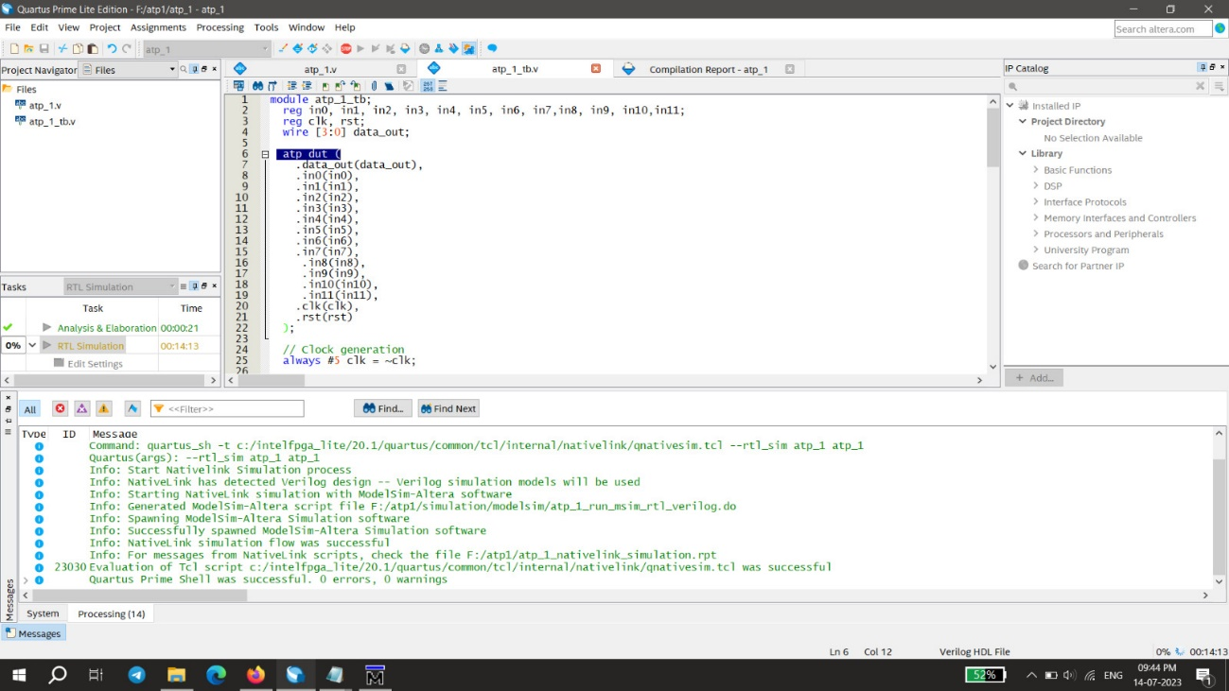

## RTL View:

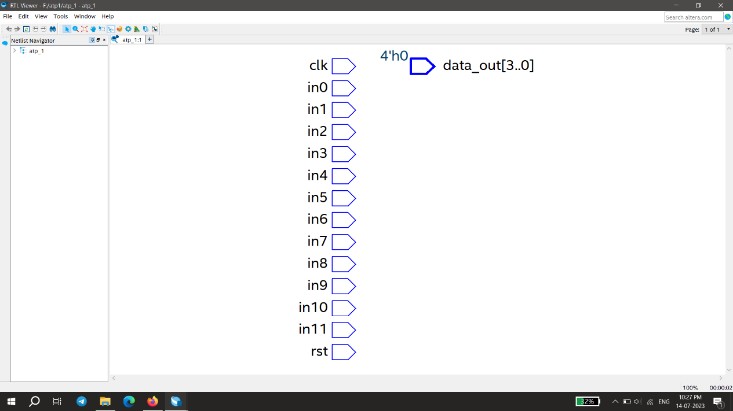

## Error in Multisim:

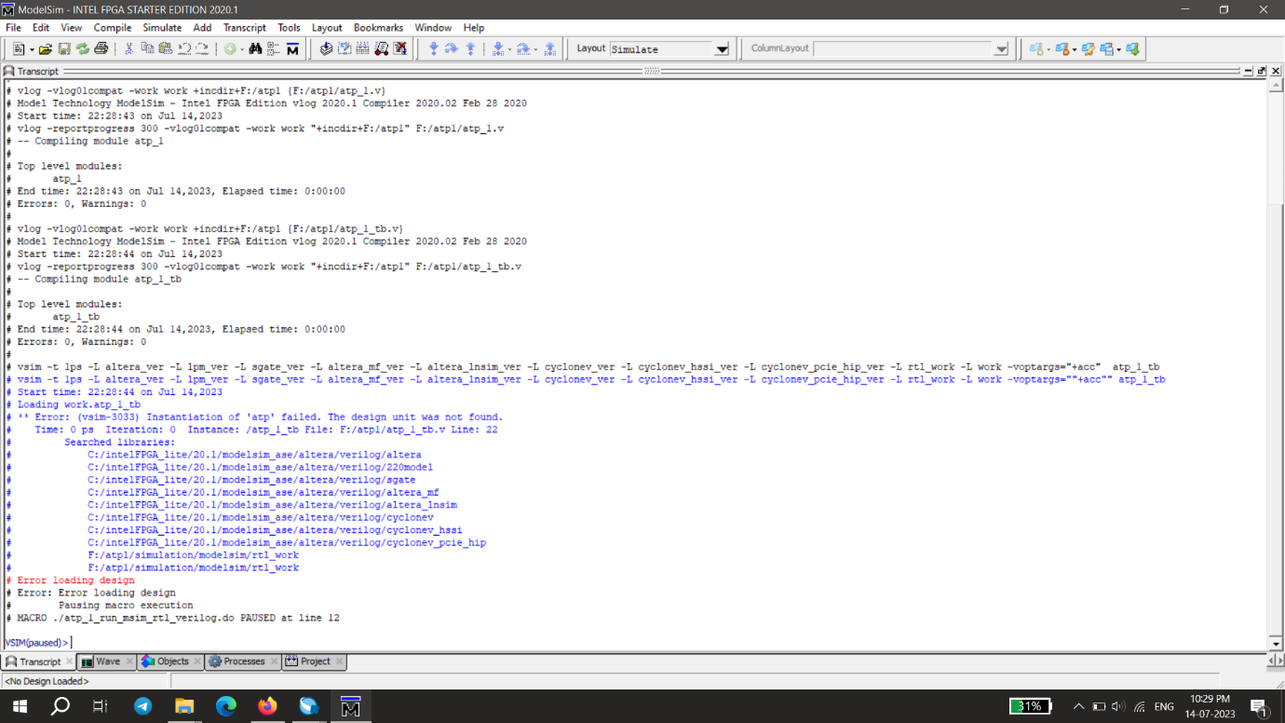

# **GITHUB FILE SCREENSHOT**

GitHub repo Link: <https://github.com/adisharma1400/TeamSpark_NMIT_ATPcontroller/tree/main/TeamSpark_NMIT_ATPcontroller>

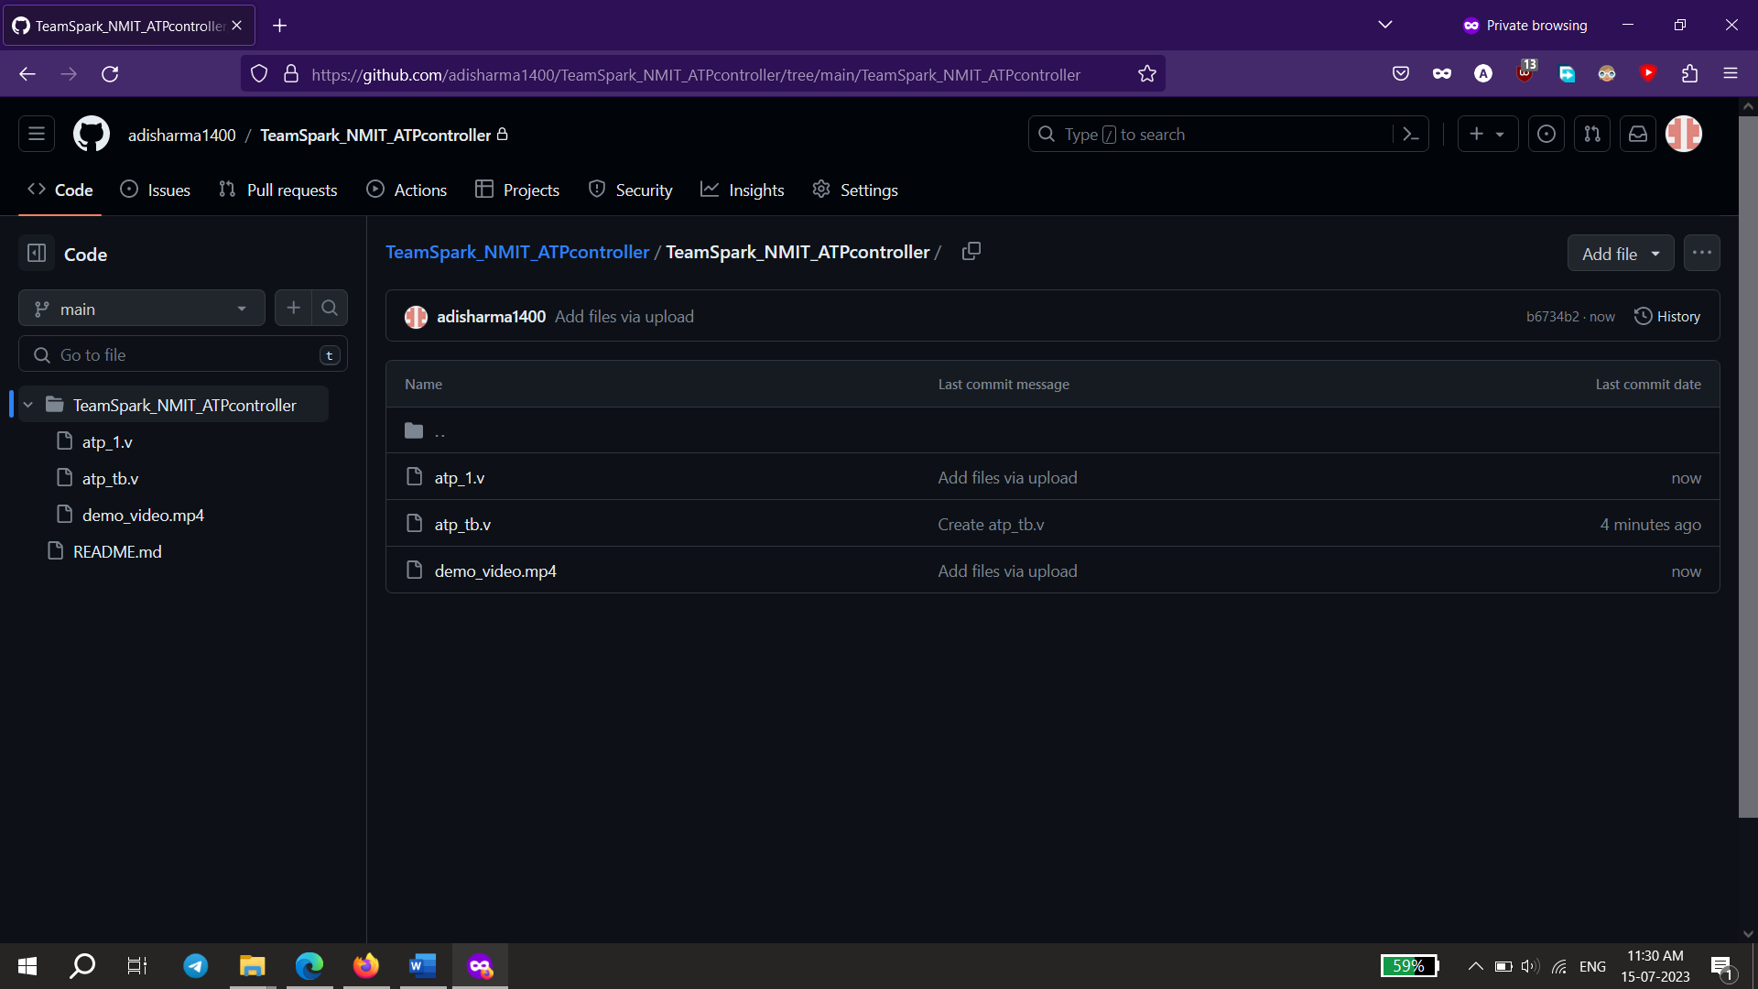

# **RESULTS AND SUMMARIZATIONS**

The main file and the test bench have been compiled without any errors. As observed due to some technical issue the RTL simulations could not be performed. Trying to troubleshoot this issue could not be done and there was also no updated documentation for the shown error.

# **REFERENCES**

1. State Machine Coding Style for Synthesis..............Clifford E. Cummings (1998)
2. System Machine Design Techniques for Verilog HDL and VHDL.......Steve Golson.